PUNJAB SKILLS DEVELOPMENT FUND

Ref: PROC/TPM/P/222
Dated: 19-07-2019
Announcement of Evaluation Report
Description | Details
Name of Procuring Agency | Punjab Skills Development Fund
Title of Procurement | Hiring of Third-Party Monitoring Services
Method of Procurement: | Quality Cost Based Selection Method
Procedure of Procurement: | Two Stage - Two Envelope Bidding Procedure
Date & Time of Bid Closing: | EOI: 08-February-19 at 03:00 PM RFP: 31-May-19 at 10:00 AM
Date & Time of Bid Opening | EOI: 08-February-19 at 03:30 PM RFP: 31-May-19 at 10:30 AM
No of Bids Received: | EOI Received = 19  Qualified for RFP = 5  RFP Received = 4  Qualified for Financial Opening = 2
Evaluation Report: | Cited Below

Eligibility:
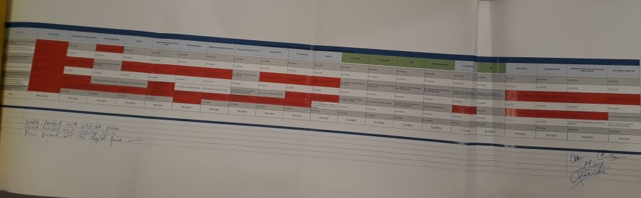

EOI – Technical Evaluation:
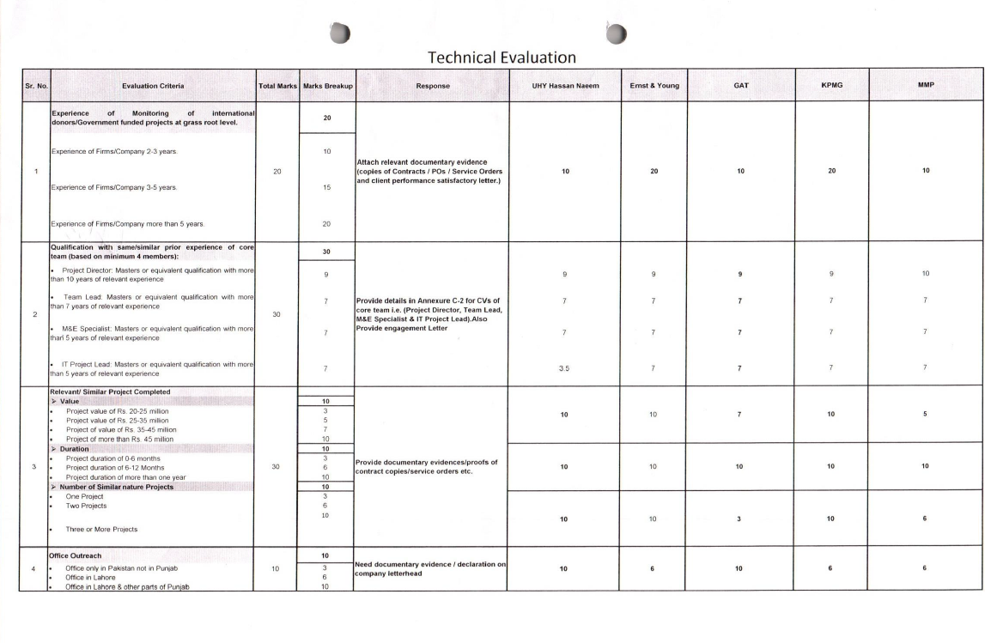

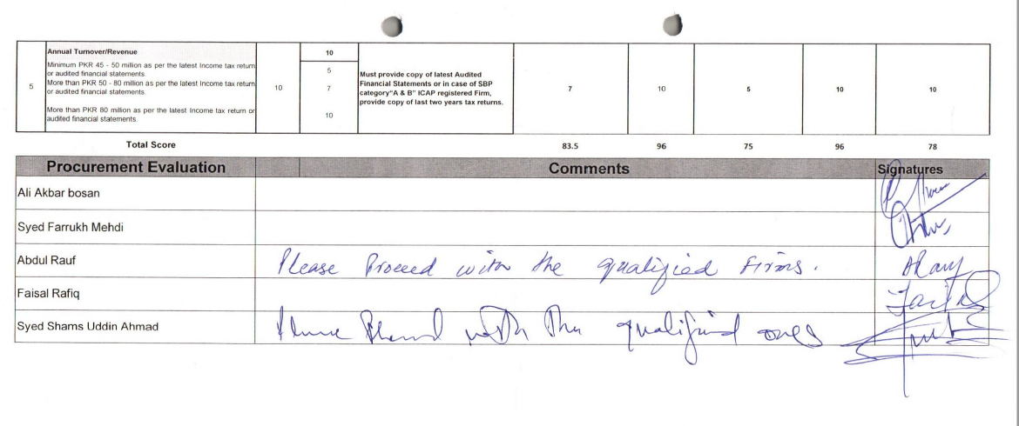

RFP - Technical Evaluation:
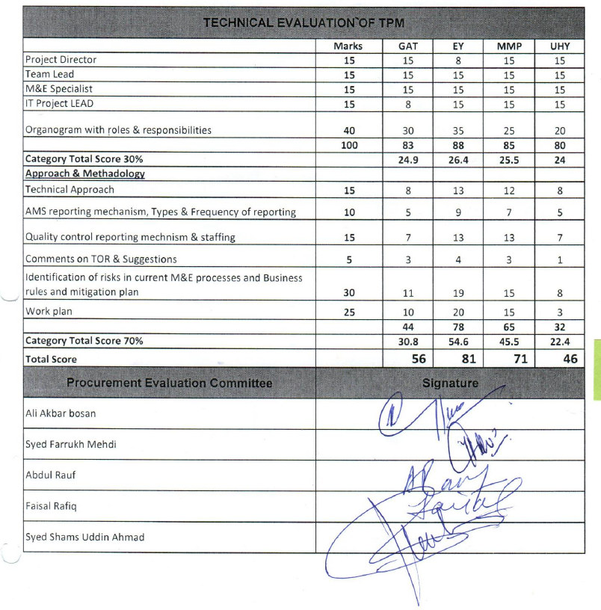

Financial Evaluation:
